

Implementation Milestones

Welcome to SimplyMerit!
We're excited to partner with you on your journey to streamline and enhance your organization's compensation planning and cycle.
This guide is your roadmap to a successful compensation cycle launch using the SimplyMerit platform. Whether you’re planning for merit, bonus, equity, or all of the above, this document will help you stay organized and aligned. It's built specifically for HR administrators like you who will configure and manage the platform.
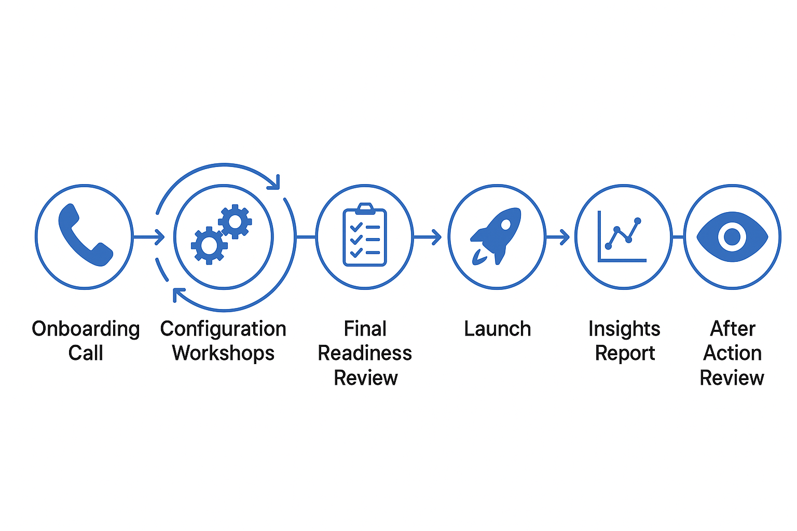

☐ Milestone 1: Onboarding Call with Customer Success Manager
Your project begins with a personalized onboarding call led by your Customer Success Manager (CSM). This session lays the groundwork for everything that follows.
Objective: Establish a strong foundation for your SimplyMerit implementation.
What you’ll cover:
- Introductions with your CSM
- Identify key stakeholders
- Discuss the overall implementation process
- Review of your implementation goals and timeline
- Confirm cycle types you'll be using (Merit, Bonus, Equity)
- Identify sources of data (e.g., HRIS, other applications)
- Clarify roles and responsibilities throughout the implementation
- Discuss the impact of change on managers
- Identify training needs
- Discuss the scheduling of Configuration Workshops
This initial meeting is your opportunity to align expectations, ask questions, and get everyone rowing in the same direction.
Onboarding Call Date: Click or tap to enter a date.
Key Takeaways:
Click or tap here to enter text.

☐ Milestone 2: Configuration Workshops
These are modular training sessions designed to build your system one core element at a time. Each workshop is hands-on, and you’ll walk away with a configured piece of your environment, clear next steps, and grow confidence in managing your setup. Each step is tailored to your needs and availabilities.
Objective: Equip HR administrators with the knowledge and skills to configure and manage SimplyMerit effectively.
Session 1: Merit Configuration & Employee Census Upload
- Explore SimplyMerit's employee census fields
- Understand how data is imported into SimplyMerit
- Configure eligibility, merit guidelines, and system controls
- Review how managers will interact with the tool
Session 2: Configuration Options Review
- Review and finalize configuration settings from Session 1
- Address any questions or adjustments needed
- Discuss manager training needs
- Review adjustment letter templates
Session 3: Bonus Plan Setup (If Applicable)
- Wrap up any outstanding questions/homework from the previous session
- Explore SimplyMerit's bonus fields and how bonus data is loaded
- Define bonus eligibility rules and targets
- Build any bonus proration logic
Session 4: Equity Configuration (If Applicable)
- Wrap up any questions/outstanding homework from previous session
- Explore SimplyMerit's equity grant fields and how equity data is loaded
- Set up equity types (RSUs, options, etc.)

Session 5: Historical Data and Remaining Configuration (If Applicable)
- Wrap up any questions/outstanding homework from the previous session
- Load historical compensation data to support reporting and context
- Ensure the fields that are required to upload changes into your HCM / Payroll systems are in SimplyMerit
- Assign delegates
- Revisit configuration settings
We recommend spacing these sessions out to allow time for hands-on practice, internal discussions, and follow-up questions.

Configuration Workshop Dates:
Merit: Click or tap to enter a date.
Configuration: Click or tap to enter a date.
Bonus: Click or tap to enter a date.
Equity: Click or tap to enter a date.
Historical: Click or tap to enter a date.

Key Takeaways:
Click or tap here to enter text.

☐ Milestone 3: Final Readiness Review
This is your pre-flight checklist: one last review to ensure everything is fully aligned and ready before you launch your cycle. We'll walk through your environment and data together to ensure you are prepared for the big day.
Objective: Validate your SimplyMerit setup before launching your compensation cycle.
What to Expect:
- Review plan setup, eligibility settings, user permissions, and adjustment letters
- Refresh employee data and budget totals (if needed)
- Test the user experience from both the admin and manager views
- Confirm internal communication strategy and timing
- Establish your launch plan and know exactly who’s doing what
This milestone is about ensuring confidence. You’ve done the work. Now let’s make sure it’s polished and ready to shine.

Final Readiness Review Date: Click or tap to enter a date.
(Recommendation: Schedule this review three days prior to launch)

Key Takeaways:
Click or tap here to enter text.

☐ Milestone 4: Launch
With everything configured and reviewed, it's time to go live. Launching your cycle means making SimplyMerit available to your selected managers and inviting them to use SimplyMerit, beginning the active compensation phase.
Objective: Finalize configuration and launch your compensation cycle with confidence.
What to Expect:
- Invite managers into the system to begin their reviews and approvals
- Use real-time tools like the Manager Activity dashboard to monitor cycle progress
- Set up and rely on reminders and alerts to keep participants on track
- Make configuration or data changes at any time—even while the cycle is live
- Reach out to the Support Team for fast assistance if anything arises
This phase is where your work pays off, but you’re never alone. We’re here to make sure things run smoothly from start to finish.

Launch Date: Click or tap to enter a date.

Key Takeaways:
Click or tap here to enter text.

☐ Milestone 5: Post-Launch Activities
Once your cycle is live, our support doesn't stop. You're entering an ongoing partnership designed to help you continue getting the most out of SimplyMerit.
Objective: Support your managers while “in cycle” and put the finishing touches on the last parts of your cycle.
What to Expect:
- Design and build your compensation or total reward letters
- Build your extract report for updating changes to your HCM / Payroll systems at the end of the cycle
- In addition to your CSM, our Support Team is always available by clicking the "Contact SimplyMerit Support" link at the top of your Configuration screen to help with technical questions, system updates, or anything urgent.
- You'll receive a handcrafted Insights Report from our consulting team highlighting trends, outliers, and opportunities within your data. Click the icon at the top of your Configuration screen to schedule the Insights Report review call. The best practice is to generate the Insights Report when managers are finished and before the changes are updated to your HRIS/Payroll systems.
- As the cycle winds, we want to hear from you! What went well? What are the opportunities for improvement? How can SimplyMerit and our team better support you? Click on the icon at the top of your Configuration screens to schedule the After-Action Review. Your feedback directly impacts our product roadmap!

Final Thoughts
Implementing SimplyMerit is a collaborative process designed to enhance your organization's compensation planning. By following these milestones and utilizing the platform's robust features, you'll be well-equipped to manage merit, bonus, and equity cycles efficiently and effectively.
Should you have any questions or need assistance at any stage, your Customer Success Manager and our Support Team are here to support you.

Need Help?
Don’t hesitate to reach out for support at any point.
📧 support@simplymerit.com 📞 or connect directly with your CSM

Thank you for choosing SimplyMerit and MorganHR.
Let’s build something great together!

Appendix: So Much More

Implementation Approach: The 'Thin Slice' Concept
The Thin Slice approach means that you don't have to wait until your compensation planning cycle is looming to get started with the SimplyMerit implementation. Thin Slice means running through a thin slice of implementation steps early, when you have more time and are not pressured by other year-end activities.
Together, we will work from A to Z, covering each step in the process. The difference is that we do not have to implement each step fully. Rather, we are taking a thin slice of the work across all the steps. Then, when your cycle nears, we refresh the data, finalize the configuration, and launch.
Why it works:
- Moves a large portion of the implementation earlier in the year when there is less pressure on the team
- Instill confidence that everything is wired correctly
- You have more time to explore the application with your data
This approach gives your team time to review, validate, and adjust without the stress of looming deadlines. Let's build it once. Cleanly and confidently.

Bringing Compensation Strategies to Life with CompAware
As you prepare for manager participation in SimplyMerit, remember that preparing managers isn’t just about using the tool—it’s about how they lead pay and performance conversations with clarity and confidence.
That’s where CompAware comes in.
You can tap into CompAware at any point in your merit cycle journey — before launching SimplyMerit, as a just-in-time refresher, or even after the system closes, to help managers prepare for conversations. It’s also a valuable year-round resource to support better pay and performance discussions across your teams.
CompAware is not a training. It’s a conversation framework designed to foster trust in your Total Rewards strategy.
A set of live, facilitated experiences that help managers and HR teams:
- Understand compensation structure and strategy in plain language
- Navigate real employee questions with transparency and empathy
- Build confidence in leading clear, equitable pay conversations
- Connect performance and pay decisions to business and team goals
Some organizations use CompAware early in their planning to strengthen rollout. Others activate it post-implementation to reinforce adoption and manager readiness. Either way, we meet you where you are — and help bring your strategy to life, conversation by conversation.
Contact your CSM to learn more, visit our CompAware web page, or schedule a discovery call here.

The Refresh Call
As your next compensation planning cycle approaches, please use this link to schedule a Refresh Call to ensure you are fully prepared for your next cycle.
During this call, we'll:
- Walk through new features or enhancements that have been added to the platform
- Update your admin list, permissions, and key contacts
- Review your last cycle's successes and any pain points
- Talk through plans and timelines for your next compensation cycle
- Fine-tune configuration settings based on your learnings from the last cycle
- Gather any enhancement requests or product feedback
- Schedule follow-ups or deeper working sessions if needed
This conversation is a great time to pause, reflect, and ensure your configuration keeps pace with your strategy. We aim to ensure SimplyMerit continues to grow with you and support your broader compensation strategy in the long term.

Beyond Compensation Cycles: Utilizing Budget Planning Mode
SimplyMerit isn't just for running compensation cycles. It's also a smart way to plan them. With Budget Planning Mode, you can model your cycle setup and financial impact before anything goes live.
What you can do:
- Model different merit, bonus, or equity spend scenarios
- Leverage the financial calculation engine in SimplyMerit
- Share draft plans with leadership and finance for early alignment
- Run forecasts and get internal feedback on guidelines or budgets
This pre-cycle setting is especially useful for testing plan logic, exploring funding needs, or identifying constraints before the launch week's pressure.
Use budget planning to plan well. Launch with confidence.

Leverage MorganHR’s Full Expertise
In addition to the SimplyMerit platform, you have access to MorganHR's team of experienced compensation consultants. Our team can partner with you to strengthen your comp strategy and expand the value of your data.
Here's how we can help:
- Offer guidance on compensation plan design and execution
- Benchmark against market best practices
- Audit your data for internal equity and pay fairness
- Facilitate custom workshops on your compensation philosophy
- Redesign your job architecture, incentive comp programs, or executive pay
This is more than just support. It's about building smarter, fairer compensation programs with trusted experts by your side.

